Certificate OF competence

Trace2O Metalyser Training workshop

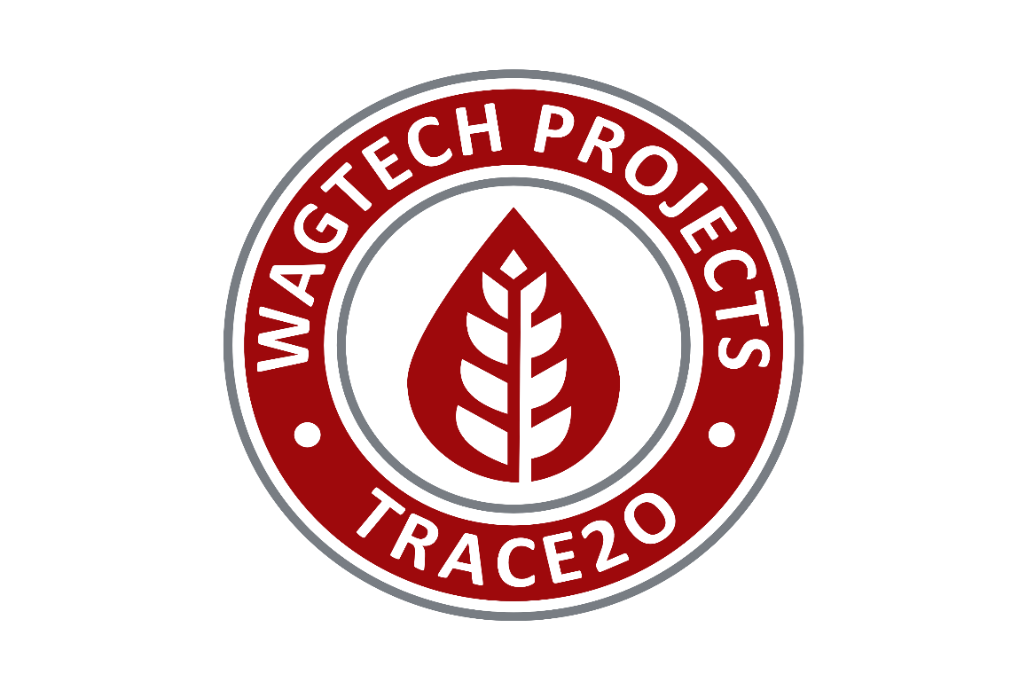
ENVIROEQUIP
Presented By: | Neil Durham CEO
DATE: | 10TH November, 2020
“Global Supplier of Cutting Edge Technologies”

